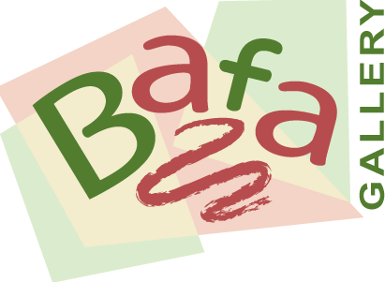

Venue Agreement

Buckingham Art for All is a local not for profit organisation that exists to support local artists of all abilities and promote their work.

They co-ordinate Bafa Gallery working with local venues who are willing to display artwork in their premises to mutual advantage: premises are enhanced; artists display, and perhaps sell, their work.

Buckingham venues who wish to participate in the Bafa Gallery initiative can request a meeting at their premises which will last up to one hour.

At the meeting Bafa representatives will discuss and agree
- available space to display artwork
- amount of artwork to be displayed
- art preferences of trader.

The agreed space must be accessible to the public during opening hours.
A commission of up to 30% is taken by the trader on any sales.

It is the Artist’s responsibility to insure their work, which they own until any sale. They retain copyright and all reproduction rights (save the advertising of the event) of the works.

In return venues will confirm they have active public liability insurance and agree to sell the artwork at their premises, covering any credit card commission or VAT costs within the commission.

Any sales monies will be settled within four weeks of sale and
replacement artwork will be offered.

Venue _______________________________________________

Sign & print name_______________________________________

Date_______________

Information: www.buckinghamartforall.co.uk
Lindsey Graham 01280 847 245
February 2021

